Copyright for test papers and marking guides remains with West Australian Test Papers.
The papers may only be reproduced within the purchasing school according to the advertised Conditions of Sale.
Test papers should be withdrawn after use and stored securely in the school until Friday 6th December 2013.


PHYSICS

2A/2B

2013

Name: _______________________________________________________

Teacher: ___________________________________________________

TIME ALLOWED FOR THIS PAPER

Reading time before commencing work: Ten minutes
Working time for the paper: Three hours

MATERIALS REQUIRED/RECOMMENDED FOR THIS PAPER

To be provided by the supervisor:
- This Question/Answer Booklet; Formula and Constants sheet

To be provided by the candidate:
- Standard items: pens, pencils, eraser or correction fluid, ruler, highlighter.

- Special items: Calculators satisfying the conditions set by the Curriculum Council for this subject.

IMPORTANT NOTE TO CANDIDATES
No other items may be taken into the examination room. It is your responsibility to ensure that you do not have any unauthorised notes or other items of a non-personal nature in the examination room. If you have any unauthorised material with you, hand it to the supervisor before reading any further.

All calculations are to be set out in detail. Marks may be awarded for correct equations and clear setting out, even if you cannot complete the calculation. Express numerical answers to two (2) or three (3) significant figures and include units where appropriate. Express estimates to one (1) or two (2) significant figures, and state any assumptions clearly.

STRUCTURE OF THE PAPER

Section | No. of  Questions | No. of questions  to be attempted | Suggested working time  (minutes) | Marks available | Proportion of  exam total
1: Short Answers | 16 | ALL | 70 | 64 | 40%
2: Problem Solving | 8 | ALL | 90 | 80 | 50%
3: Comprehension and  Interpretation | 1 | ALL | 20 | 16 | 10%

Note: Above refers to 3 hour paper.

INSTRUCTIONS TO CANDIDATES

Write your answers in the spaces provided beneath each question. The value of each question (out of 160) is shown following each question.

The enclosed Physics: Formulae and Constants Sheet may be removed from the booklet and used as required.

Calculators satisfying conditions set by the School Curriculum and Standards Authority may be used to evaluate numerical answers. The calculator cannot be a “graphics” calculator.

Answers to questions involving calculations should be evaluated and given in decimal form. Final answers should be given up to three significant figures and include appropriate units where appropriate. Despite an incorrect final result, credit may be obtained for method and working providing these are clearly and legibly set out.

Questions containing specific instructions to show working should be answered with a complete, logical, clear sequence of reasoning showing how the final answer was arrived at; correct answers which do not show working will not be awarded full marks.

Questions containing the instruction "ESTIMATE" may give insufficient numerical data for their solution. Students should provide appropriate figures to enable an approximate solution to be obtained.

Section 1: Short Answers

Marks allocated: 64 marks out of a total of 160 (40%)
Suggested working time: 70 minutes

Attempt ALL questions in this section. Not all questions attract the same marks.

Answers are to be written in the space below or next to each question.

Question 1 (3 marks)
Answer TRUE or FALSE to each of the following.
(a) When 200.0 g of water is heated from 10 ºC to 50 ºC it has absorbed the same quantity of heat as when it is heated from 60 ºC to 90 ºC. ____________________________

(b) When 200.0 g of water cools from 50 ºC to 10 ºC it gives off the same quantity of heat as when it cools from 90 ºC to 50 ºC. _________________________________

(c) When 200.0 g of water is heated from 20 ºC to 60 ºC it has absorbed the same quantity of heat as when lead is heated from 20 ºC to 60 ºC. _____________________________

(specific heat capacity of water is 4.18 x 10³ J kg⁻¹ K⁻¹
specific heat capacity of lead is 1.28 x 10² J kg⁻¹ K⁻¹)

(3 marks)

Question 2 (4 marks)
A tray containing 700 mL of water at 20 ºC is placed in the freezer compartment of a refrigerator. How much heat must be removed from the water for it to become ice at -4 ºC? (4 marks)

Question 3 (2 marks)
Name a safety feature in modern houses that limits the risk of receiving an electric shock and describe how it works. (2 marks)

Question 4 (4 marks)
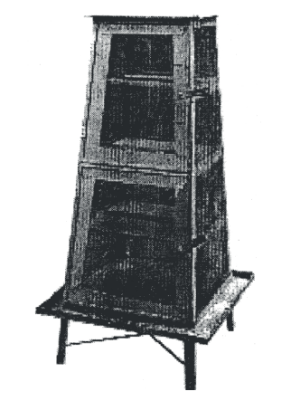
A Coolgardie safe was used to keep food cool before refrigerators were commonly used in Australian Homes.
It was simply a box on a stand placed outside a house. The sides of the box were covered in a water absorbing material such as cotton or hessian. The material was kept wet.

a) Briefly explain how the Coolgardie safe was able to keep its contents cool. (2 marks)

b) Explain how the effectiveness of the Coolgardie Safe would change in humid conditions. (1 mark)

c) State one factor that could be changed to increase the rate of cooling in the safe. (1 mark)

Question 5 (3 marks)

The average power applied by an adult’s heart for circulating blood in the body is about 1.50 W.
- How much work does an adult human heart do in an hour? (1 mark)

- If this amount of work is used to lift a 50.0 kg object at constant velocity, calculate the theoretical maximum height to which the object can be raised? (2 marks)

Question 6 (4 marks)
A worker on a building site accidently dropped a 4.00 kg hammer and it fell 12.0 m to the ground.
(a) Calculate the speed of the hammer when it hit the ground. (2 marks)

(b) If the impact time of the hammer hitting the ground was 0.300 seconds, calculate the magnitude of the average force exerted on the ground during the impact. (2 marks)

Question 7 (4 marks)
The cathode ray tube in a television set accelerates electrons from rest through a potential difference of 120.0 kV.
- How much energy, in joules, does each electron gain in being accelerated in this field? (2 marks)

- If the energy gained by each electron is 98% kinetic, what velocity will the electron have after undergoing this acceleration? (2 marks)

Question 8 (2 marks)
A shop assistant opens a bottle of perfume to demonstrate the fragrance to a customer. Within a few seconds the smell of the perfume can be detected by another shopper who is standing several metres away. Using your understanding of the kinetic molecular theory, explain why the perfume can be detected several metres from the open bottle. (3 marks)

Question 9 (4 marks)
When it is not convenient to connect your iPad to the mains to recharge it, a portable charger can be used. A typical portable charger can deliver 3.0 V with a current of 1.9 A.

- If the device is connected to the iPad for 2.5 hours, how much charge flows from the portable charger to the iPad in that time? (2 marks)

- How much work is done in moving the charge? (2 marks)

Question 10 (3 marks)
A four outlet power board (see photo opposite) used to connect a computer, printer and desk lamp to a single 240 V outlet, is rated for a maximum current of 8.00 A. Why shouldn’t an electric heater, rated at 240 V and 2.50 kW, be plugged into the fourth outlet on the power board? Explain, and support your answer with calculations. (3 marks)
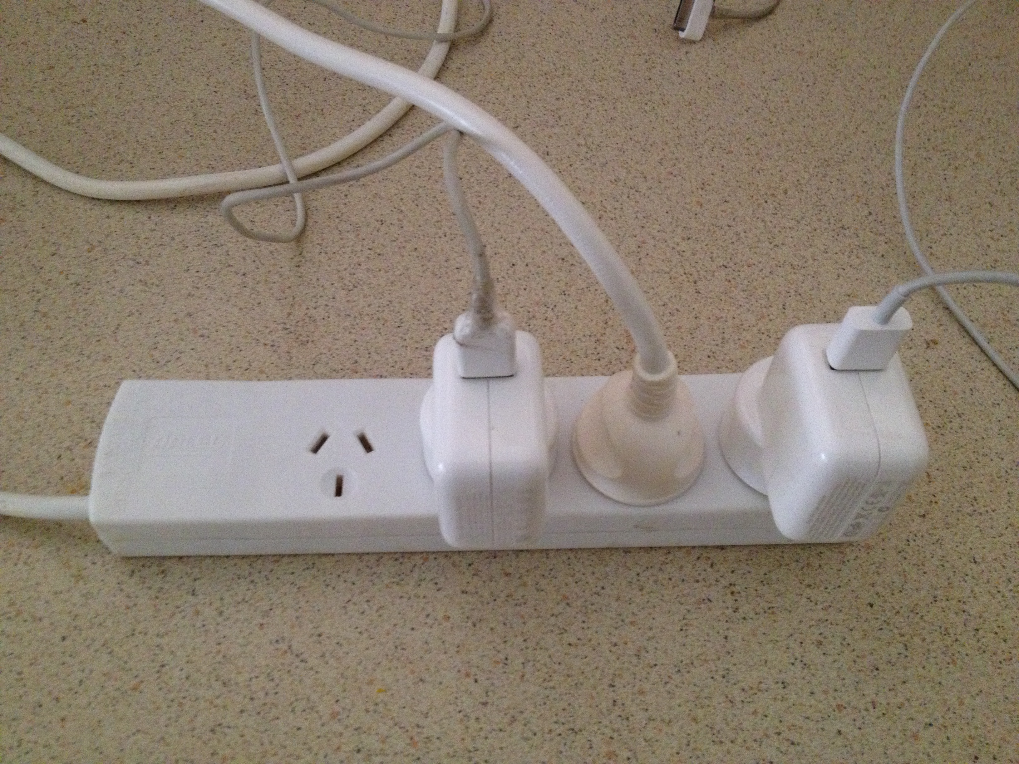

Question 11 (4 marks)
A fully loaded A 380 Airbus having a mass of
5.60 x 10⁵ kg takes off at an angle of 20º
to the runway and is propelled forward by
its four engines.
(a) On the photo opposite draw arrows to
show the forces that are acting on the
aircraft as it takes off. (2 marks)
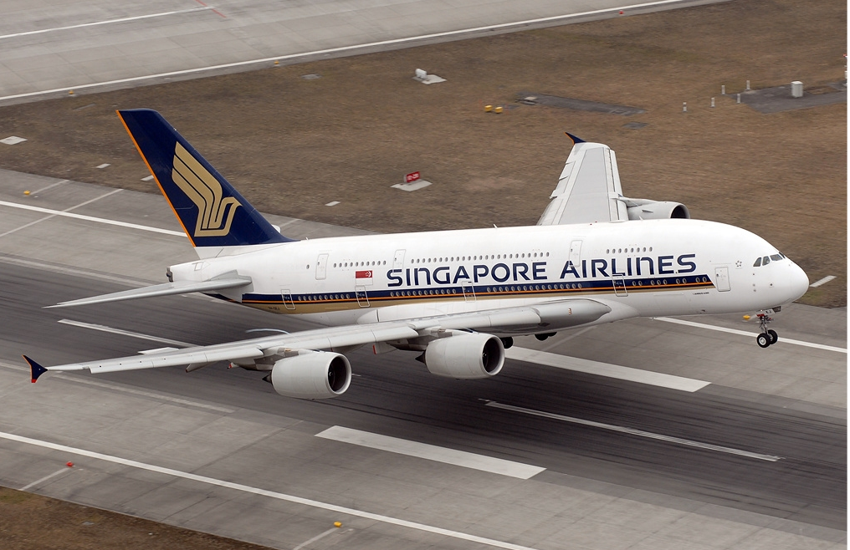

(b) Calculate the minimum vertical force that the engines need to produce to just lift the Airbus
off the runway. (2 marks)

Question 12 (6 marks)
Nuclear fusion is a major source of energy in the Universe. One fusion reaction involves the combination of four protons and two electrons to form a helium nucleus, two neutrinos (υ) and six photons (γ). Neutrinos and photons have no mass. The overall equation for this reaction is:

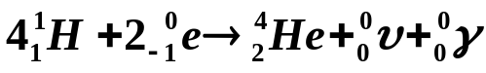

- Calculate, in joules, the energy released from this process due to the mass defect. (4 marks)

- Convert your answer above to MeV (if you couldn’t answer part a), use
E = 3.76 x 10⁻¹² J) (2 marks)

Question 13 (6 marks)
(a) Complete the following nuclear equations and name the particle / radiation type.
(4 marks)
(i) 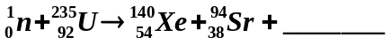

Name of particle____________________

(ii) 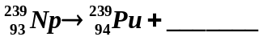

Name of particle_____________________

(b) Write balanced nuclear equations for the following decays. (2 marks)

- Iodine -131 by beta negative decay.

- Radon – 220 by alpha decay

Question 14 (5 marks)
A 161.0 g cricket ball moving at 25.0 m s⁻¹ hit the edge of a stationary bat transferring 18.1 J of energy to the bat.
(a) Calculate the speed of the ball after the collision. (3 marks)

(b) The ‘hot spot’ image of the collision taken at the instant of impact shows that about
4.0 g of bat wood absorbed the 18.1 J of energy and increased the temperature of that portion of the bat. Estimate the temperature increase of that portion of the bat.

(The specific heat capacity of the bat wood is 2.25 x 10³ J kg⁻¹ K⁻¹) (2 marks)

Question 15 (4 marks)
(a) A common way of keeping warm in bed during cold nights is to cover ourselves with blankets. Explain briefly how blankets keep us warm by referring to the three (3) methods of heat transfer: conduction, convection and radiation. (3 marks)

(i) Conduction

(ii) Convection

(iii) Radiation

(b) Some people prefer a doona instead of blankets to keep warm. (A doona is an envelope of fabric filled with either feathers or fibre). Describe in terms of heat transfer the major advantage of a doona compared to blankets. (1 mark)

Question 16 (6 marks)
A 50.0 g ball is hit vertically into the air with a tennis racquet. The ball travels 15.5 m before reaching its maximum height and returns to the exact position from which it was hit.
(For the following questions assume negligible air resistance).

- With what speed did the ball leave the racquet? (2 marks)

- What was the ball’s speed at its maximum height? (1 mark)

- How long did the ball take to reach its maximum height? (2 marks)

- Calculate the speed of the ball when it had travelled 31 m. (1 mark)

END OF SECTION 1

Section 2: Problem Solving

Marks allotted: 80 marks out of a total of 160 (50%)

This section contains 8 questions. Suggested working time is 90 minutes.

Question 17 (12 marks)

A complex circuit diagram is shown below.

B
15 Ω
10 Ω
4 Ω
30 Ω
18 Ω
9 Ω
emf 120 V
A
D
C

- Calculate the effective resistance of the circuit between points A and D. (3)

- Calculate the current through the 4.00 Ω resistor. (2)

- Calculate the potential difference across the 30.0 Ω resistor.
(3)

- Calculate the current flowing through the 18.0 Ω resistor.
(2)

- Calculate the power output of the 9.00 Ω resistor.
(2)

Question 18 (12 marks)
In a 50.0 km long distance race involving an able -bodied runner and a wheelchair athlete, the able-bodied runner maintained an average speed of 17.0 km h⁻¹ for the race. The wheelchair athlete can go faster and so in order to make it a fair race, he set off 30.0 minutes after the able-bodied runner and travelled at an average of 21.0 km h⁻¹ for the race.

(a) Calculate how long it took for the able-bodied runner to finish the race. (2 marks)

(b) Calculate how long it took for the wheelchair athlete to finish the race, including the half hour he waited at the start. (2 marks)

(c) Who won the race? Support your answer with calculations and clear reasoning. (2 marks)

(d) By how many minutes did the winner beat the loser? (2 marks)

(e) When the winner crossed the finish line how much further did the loser have to travel before they finished? (2 marks)

(f) What average speed would the loser of the race have had to maintain, just to finish at the same time (that is, draw the race), as the winner? (2 marks)

Question 19 (12 marks)
When a uranium-235 nucleus absorbs a neutron, many fission products are possible. One such reaction in a nuclear power plant results in the formation of lanthanum-148 (La), bromine-85 (Br) and neutrons.
(a) Write an equation for this reaction. (3 marks).

(b) How many neutrons are produced in this reaction? (1 mark)

(c) The waste removed from the power plant had a measured activity of 128.0 Bq above the background count of 2.00 Bq. What is meant by the term ‘background count’?
(2 marks)

(d) Give an example of a source of background radiation. (1 mark)

(e) The radiation monitor worn by an 85.0 kg worker at the power plant indicated he had absorbed 24.0 J of energy when exposed to the nuclear waste. Calculate the dose he had absorbed. (2 marks)

(f) Determine the dose equivalent for the worker, assuming 90% of the radiation was from gamma radiation and 10% from alpha. (3 marks)

Question 20 (9 marks)

In an experiment to demonstrate how efficiently electrical energy is transformed into heat energy, a student set up an electrical circuit containing a nichrome wire heating coil immersed in a glass beaker of water. The circuit was switched on and the time to bring the water to its boiling point was recorded.

Data collected from the experiment.
Volume of water = 100.0 g
Initial temperature of the water = 21.0 ºC
Time for water to reach boiling point = 20 min
Steady reading on the voltmeter = 12.0 V
Steady reading on the ammeter = 2.50 A

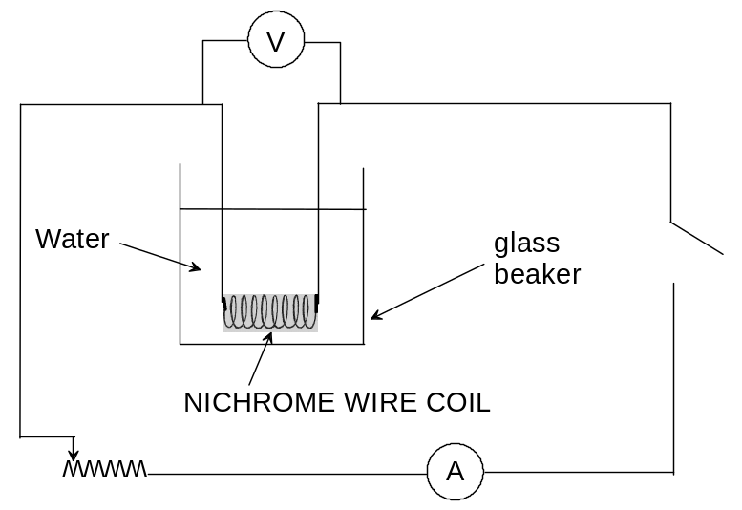

(a) Calculate the quantity of electrical energy produced by the circuit. (2 marks)

(b) Calculate the quantity of heat energy absorbed by the water. (2 marks)

(c) Calculate the efficiency of the system if the aim is to conserve energy between the heating coil and the water. (2 marks)

(d) Explain why the efficiency is not 100%. (2 marks)

(e) Suggest one improvement that could be made to increase the efficiency of the system. (1 mark)

Question 21 (11 marks)

Carbon-14 is formed in the upper atmosphere by the interaction of nitrogen and cosmic rays that results in the N-14 atom of 7 protons and 7 neutrons absorbing a high speed neutron and ejecting a proton, hence being transformed into a C-14 atom of 6 protons and 8 neutrons.
Living creatures take in C-14 as part of the carbon in their CO₂ intake (plants) or food intake (animals).
The decay curve for a typical sample of C-14 is given below.
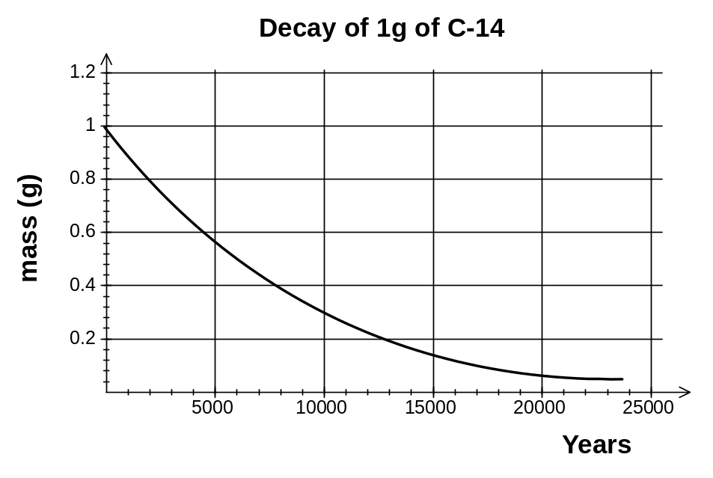

- (a) Write an equation to show the process involved in the formation of C-14. (2 marks)

(b) From the graph above estimate a value for the half-life of C-14. (1 mark)

A wooden relic having a mass of 0.50 kg is discovered during an archaeological dig. When tested with a Geiger counter it registers 560 counts in 1.00 hour. A modern piece of similar wood and the same mass produces 0.325 Bq of ionizing radiation.

c) Explain why the wooden relic is radioactive (2 marks)

d) What is the activity of the relic’s radiation in becquerals (Bq)? (2 marks)

e) Give an approximate age of the relic, using your estimate of the half life calculated in part b). (2 marks)

f) A UWA zoologist who knows little about physics studies kangaroos. He is interested to know if younger kangaroos are more prone to getting killed on highways than older kangaroos. His plan is to collect freshly killed kangaroos from the roads and use radiocarbon dating to find out how old the animals were when they died. Explain why this won’t work. (2 marks)

Question 22 (9 marks)
A Formula One racing car accelerates uniformly from rest to a speed of 250.0 km h⁻¹ in 4.50 s and then travels at that speed for the next 3.00 s.

(a) On the graph grid below, represent the speed versus time of the car. Label the axes and include scales and units for speed and time. (2 marks)



(b) The acceleration of the car can be determined by using the graph. DESCRIBE how you could use the graph to determine the acceleration. (2 marks)

(c) Use the graph in the way you described in (b) above, to determine the acceleration, in
m s⁻² of the car during the first 4.5 s. (2 marks)

(d) Calculate the distance the car travelled in 7.5 s. (3 marks)

Question 23 (8 marks)
Some students conducted an experiment to determine the latent heat of fusion of ice.
They followed the method below:
- Warm water was placed into a copper calorimeter and the temperature recorded.
- An ice cube at 0.00 °C was dried with a paper towel.
- The ice cube was placed in the warm water in the calorimeter and the final temperature was recorded when the melted ice, the water and the calorimeter had reached thermal equilibrium.
- Results were recorded in the table below.

Table of results:

Measurement | Data
Mass of copper calorimeter | 73.0 g
Mass of calorimeter + warm water | 159 g
Mass of calorimeter + warm water + ice | 193 g
Mass of warm water
Mass of ice
Initial temperature calorimeter + warm water | 41.6 °C
Final temperature calorimeter + warm water + melted ice | 9.00 °C
Temperature change calorimeter + warm water
Initial temperature of ice | 0.00 °C
Temperature change of melted ice (water) in calorimeter | 9.00 ºC

(a) Complete the table by filling in the blanks. (Some of the values have been done for you.)
(2 marks)

(b) Use this data to calculate the latent heat of fusion of ice in this experiment. (6 marks)

      - The specific heat capacity of copper is 380 J kg⁻¹ K⁻¹

Question 24 (7 marks)

(a) Resistors can be either ohmic or non-ohmic. Describe how these two types of resistors differ. (2 marks)

(b) An ohmic resistor labelled 5.0 W is in an electrical circuit where the potential can vary from 1.0 V to 100.0 V.
(i) Calculate the range of current that will flow in it. (2 marks)

(ii) Calculate the energy that will be dissipated in the resistor each second when a current of 5.0 A is flowing through it. (1 mark)

(iii) What factors determine how much power is dissipated in the ohmic resistor? (2 marks)

END OF SECTION 2
Section 3: Comprehension
(Marks allocated: 16 marks out of 160 (10%). Suggested working time 20 minutes.
_______________________________________________________________________________
Article: ‘Electric shocks’
Paragraph 1
Death caused by an electric shock is called electrocution. There were 550 electrocutions in the US in 1993, which translates to 2.1 deaths per million inhabitants.
Paragraph 2
The minimum current a human can feel depends on the current type (AC or DC) and frequency. A person can feel at least 1 mA of AC at 50 Hz, while at least 5 mA for DC. The current may, if it is high enough, cause tissue damage or fibrillation (rapid irregular heartbeat) which leads to cardiac failure. 60 mA of AC at 50 Hz or 300–500 mA of DC can cause fibrillation. If not immediately treated by defibrillation machines, fibrillations are usually lethal because all the heart muscle cells move independently instead of in the coordinated pulses needed to pump blood.
Paragraph 3
If the voltage is less than 200 V, then the human skin is the main contributor to the resistance of the body in the case of a macroshock—the passing of current between two contact points on the skin. The resistance characteristics of the skin are non-linear however. If the voltage is above 450–600 V, then molecular breakdown of the skin occurs. The protection offered by the skin is lowered by perspiration, and this is accelerated if electricity causes muscles to contract above the “Let-go threshold” for a sustained period of time.
Paragraph 4
If an electrical circuit is established by electrodes introduced into the body (e.g. probes attached to internal organs) then the potential for fatality is much higher if a circuit through the heart is established. This is known as a microshock and currents of only 10 µA can be sufficient to cause fibrillation in this case. This is a concern in modern hospital settings when the patient is connected to multiple devices.
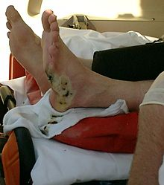
Burns
Paragraph 5
It is a relatively unknown fact that more electrical workers die from burns than from an electric shock. In fact, only around 20% of deaths are the result of electric shock itself. Voltage levels of 500 to 1000 volts tend to cause internal burns due to the large amount of energy produced.
Second-degree burn after a high tension line accident

Paragraph 6
The heat produced may cause severe burns, especially on unprotected flesh. The blast energy produced by vaporizing metallic components can break bones and irreparably damage internal organs
The formula for this burn energy is E = v²t / R_{B}
where v = applied voltage in volts
t = time of exposure in seconds
R = body resistance in ohms
Neurological effects
Paragraph 7
Current can cause interference with nervous control, especially over the heart and lungs. Police forces now use the "Taser", which fires projectiles that administer the shock through a thin, flexible wire and incapacitates the nervous system without permanent damage.
Body resistance
Paragraph 8
The voltage necessary for electrocution of a person depends on the current through the body and the duration of the current. Ohm's law states that the current drawn depends on the resistance of the body. The resistance of human skin varies from person to person but in dry conditions, the resistance offered by the human body may be as high as 100,000 ohms. Wet or broken skin may drop the body's resistance to 1,000 ohms and high voltage electrical energy quickly breaks down human skin and may reduce the human body's resistance to 500 ohms.
The International Electro Technical Commission gives the following values for the total body resistance of a hand to hand circuit for dry skin. Table 1 shows how average Total Body Resistance varies with voltage for an average of 95% of the population.

Shock Voltage (V_{S})  Table 1 | Body Resistance R_{B} (k Ω)
25 | 6.1
100 | 3.2
220 | 2.125
1000 | 1.5
a) Which seems to be more hazardous to humans when receiving an electric shock, an alternating or a direct current? Justify your answer with information from the article. [2 marks]
__________________________________________________________________________________________________________________________________________________________________________________________________________________________________________________________________________________________________________________________________________________________________________________________________________________________________________________________________________________________________________________________________________
b) Why is it that hospital patients are particularly susceptible to electrocution from smaller voltages than normal? [2 marks]
__________________________________________________________________________________________________________________________________________________________________________________________________________________________________________________________________________________________________________________________________________________________________________________________________________________________________________________________________________________________________________________________________________
c) Use Table 1 and other data from this article to calculate the burn energy received by a victim who touches a 1000 V high tension cable for a time of 100 ms. [3 marks]

d) In Paragraph 3 it mentions that “The resistance characteristics of the skin are non-linear however”. What evidence can you give in this article to support this statement? [2 marks]
___________________________________________________________________________________________________________________________________________________________________________________________________________________________________________________________________________________________________________________________________________________________________________________________________________________________________________________

e) A research medical physicist has a hypothesis that R_{B} is related to V_{S} by the formula: 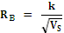where k is a constant.
Complete Table 2 below by inserting values into the blank, right-hand column. [2 marks]
Shock Voltage (V_{S}) | Body Resistance R_{B} (Ω) | Reciprocal of root V_{s,} (Volt ^{-1/2})
25 | 6,100
100 | 3,200
220 | 2,125
1000 | 1,500
Table 2

f) Plot a graph on the paper below of R_{B} (y-axis) versus (x-axis) [3 marks]



g) Use the graph to provide evidence as to whether the physicist’s hypothesis might be correct. [2 marks]

END OF EXAM
Additional working space

Additional working space

Additional working space

Additional working space

